CV of Dr. Rachel Kabi

Name: Dr. Rachel Kabi
Designation: Assistant Professor
Address for Communication: (office) Department of Social Work
Girijananda Chowdhury University
Azara, Haatkhowpara – 781 017
Mobile No.: 8729982751
WA No: 8729982751
Email: rachel_kabi@rediffmail.com

Sex: Female
Date of Birth: 20/10/1970
Educational Qualifications:
Sl. | Examination Passed | Year of passing | Board / Council /
No. |  |  | University | Specialization
1 | HSLC/10th Std. | 1986 | Anglo-Indian High School Examination
2 | HSSLC/10+2 Std. | 1988 | Tamil Nadu Board of Higher Secondary Examination | Mathematics, Physics, Chemistry and Computer Science
3 | Degree (Please Specify) | 1991 | UNIVERSITY OF MADRAS | ENGLISH LITERATURE (University Rank – 3rd Rank)
4 | Master’s Degree  (Please Specify) | 1993 | UNIVERSITY OF MADRAS | SOCIAL WORK (Specialization in Medical and Psychiatry)
5 | M. Phil.(Please Specify) | N/A | - | -
6 | Ph. D. (Please Specify) | 2017 | ASSAM DON BOSCO UNIVERSITY | SOCIAL WORK
7 | Post-Doctoral  (Please Specify) | N/A | - | -
8 | Others(Please Specify) | 1993 | UGC/NET | SOCIAL WORK

Languages known: Tamil, English
(Read, Write & Speak)

Academic/ Administrative Experience:
-Academic Experience: Five years of Teaching Experience
18 years of Industrial Experience

List of Publications:
Books/Articles
Jose K., & Kabi R. (2023). Arunachal Pradesh: Re-inventing a Frontier Ethno-Space (Ed). Global Publishing House India: Visakhapatnam. ISBN No: 978-93-95606-69-1
Kabi R., & Kabi Kh. (2017). Challenges Confronting Women in Media. Journal of Humanities and Social Sciences (A National Refereed Bi-Annual Journal), Mizoram University. III (2). Pp 114 – 122. ISSN. 2395-7352.
Kabi R., & Pereira M. (2017). Understanding Delinquency as a Sequel of Father–Son Relationship. Journal of Northeast Indian Cultures (A Peer Reviewed International Journal devoted to Social, Philosophical and Religious Underpinnings of the Region), 3(2), 101 - 123. (2017).
Kabi R., & Pereira M. (2016). Life after detention: The voice of young offenders in the juvenile justice system. InterViews: An Interdisciplinary Journal in Social Sciences, 3(1), 34 – 52.
Kabi R., & Pereira M. (2016). Interplay of family disruption paradigm and juvenile delinquency. Anthropology Today: An International Peer Reviewed NEIRA Journal, 1(2), 209 – 228. (2016).
Kumar M.S., Natale R.D., Langkham B., Sharma C., Kabi R., & Mortimore G. (2009). Opioid substitution treatment with sublingual buprenorphine in Manipur and Nagaland in Northeast India: What has been established needs to be continued and expanded. Harm Reduction Journal, 6:4. Doi: 10.1186/1477-7517-6-4
Papers Presented:
- ‘Trafficking and Poverty – plight of young girls from Assam (India) – presented at the “Poverty and Social Protection Conference 2014’ held during 9 – 11 March, 2014, Bangkok, Thailand
- ‘Effectiveness of Community Based Addiction Treatment Camp’- presented at the National Conference of Professional Social Workers in 1998.
- Presented a paper on “Brief Therapy” and also implemented it with Alcoholics at TTK Hospital, Chennai.
- ‘Women in Treatment’ presented at the National Conference of Professional Social Workers in 2000.

Research Experience:

- Doctoral thesis guided : N/A
- Research & Consultancy Projects:
- Project on Positive Fatherhood Project of IGSSS (Indo-Global Social Service Society), New Delhi carried out at Arunachal Pradesh (August 2019).
- Principal investigator in the project ‘Strengthening and Expanding Interventions for Persons with Mental Disorders in the North-East Region, Phase- III’ sponsored by Sri Ratan Tata Trust, Mumbai and Ashadeep, Guwahati (August 2013 till June 2014).
- Conducted Training Need Assessment of the Caregivers in the Children’s Institutions in Assam as commissioned by UNICEF, Assam (2012).
As a Resouce Person: 2007 till date
Has been a regular trainer in the State level and Regional level Consultations/Workshops on Counselling, HIV/AIDS, Child Protection, the Juvenile Justice System, Adoption & Alternative Care Programmes organized by the Government of Assam (Dept. of Social Welfare, Dept. of Home Affairs and the Judiciary), Government of Nagaland, NIPCCD Regional Centre and NGOs.

Membership of Professional bodies:
Award, Fellowship & Recognition:

- Former Member of the Committee constituted through Official Gazette Notification of the Government of Assam to oversee the preparation of Conceptual Roadmap for the successful rescue and rehabilitation programme for child victims in the State of Assam.
- Former Member of State Level Selection Committee constituted through Official Gazette Notification of the Government of Assam for selection of members of the Juvenile Justice Boards and Child Welfare Committees in Assam

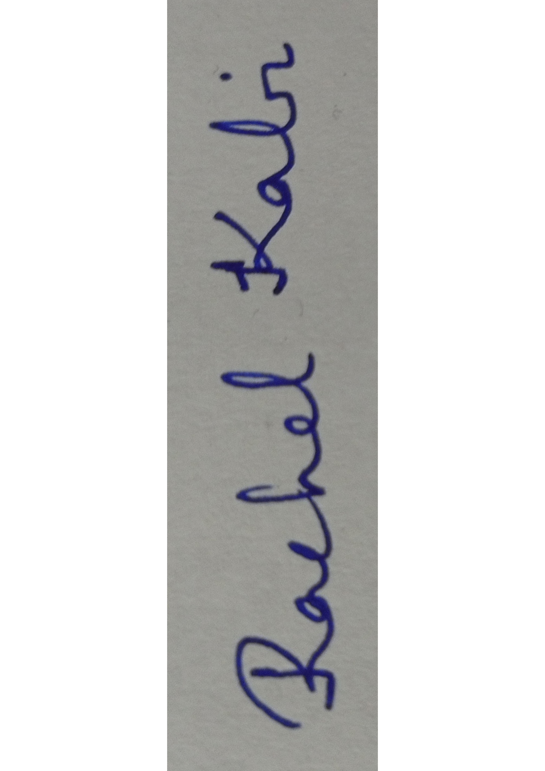
Scanned Signature
Date: 8th May 2023 (Rachel Kabi)

